**FOOD BANK ANALYSIS FOR JANUARY 2018**

After the very hectic months running up to Christmas, the Food Bank has calmed down a little. Our services have been called upon by 78 people this month (43 adults and 35 children). It’s been good to have a little more time to chat with people and catch up with things that needed doing – date checking the large amount of tinned food that is at present stored in The Lodge for one. My thanks go to Liz and Jean P. who have done a great job.

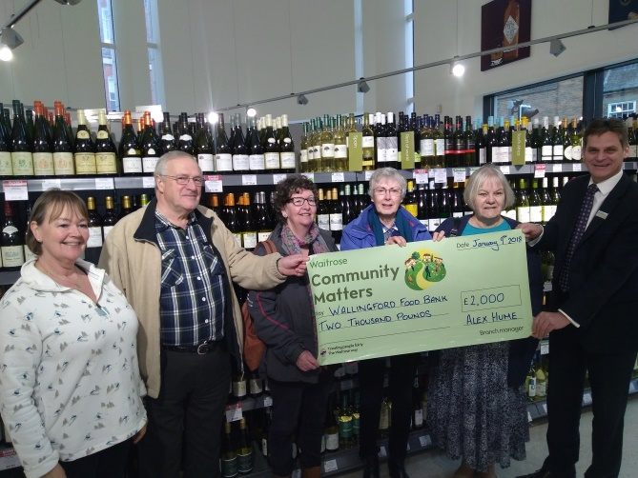

In my last report I said ‘watch this space’ with regard to further storage. I can now tell you that at the beginning of this month we were invited to go along to Waitrose and collect a cheque for £2,000 which would go towards purchasing a half size shipping container, to be housed in the Council Parks and Gardens yard (the other side of the Bullcroft Park from where we operate). We are enormously grateful to Waitrose for their generous gift and also to Councillor Deborah Whelan for putting the wheels in motion with regard to this move. The container will obviously have to be kitted out with shelving and some form of lighting and heating and we are hoping to buy a four wheel trolley which will enable us to transport stock from storage to the Food Bank cupboards. It will also mean that we should be able to take the remaining food from our house (of which there is still quite a bit) so that all overflow stock will be in one place. This is a great start to the year for us and I should like to thank all those of you who have been praying about this issue and I know quite a few of you have.

My thanks once again also go to all those who so generously contributed all sorts of goodies for Christmas. I must confess that I was worried that we wouldn’t move it all by the time the ‘sell by’ dates arrived, but move it we have and we have even had to go shopping a couple of times to stock up on those staple items that we run short of ie; milk, fruit juice, cereal, hot dogs, corned beef and sugar.

The clients that we help are so touched by the food that we give out. Our headed paper has the text ‘I was hungry and you gave me something to eat’, I am so pleased that we are able to do this.

*Jean Burt*